Chapter 14
TensorBoard: Big Brother of TensorFlow

The story begins with the recognition that building neural networks is only one part of the journey. Just as important is the ability to observe what is happening inside them, to track whether the data has been correctly prepared, and to detect when models drift away from learning effectively. To serve this purpose, TensorBoard emerges as a visual companion, transforming abstract tensors and training logs into interpretable dashboards. By organizing experiments into timestamped directories, it enables the researcher to compare multiple runs, follow progress over time, and spot unusual behaviors before investing too much training time.
A concrete illustration comes from image recognition of garments. The Fashion-MNIST dataset provides a set of 28×28 grayscale clothing images across ten categories, including shirts, dresses, and sneakers. After constructing training, validation, and testing datasets, images are logged through TensorBoard writers. Once opened, the dashboard presents them as labeled samples, ensuring they have been loaded with the correct categories. Beyond images, TensorBoard supports scalars, histograms, audio, and text, making it versatile for numerous data modalities. A visualization example (Figure 1) demonstrates how logged images can be browsed interactively, brightness and contrast adjusted, and data folders selectively viewed.
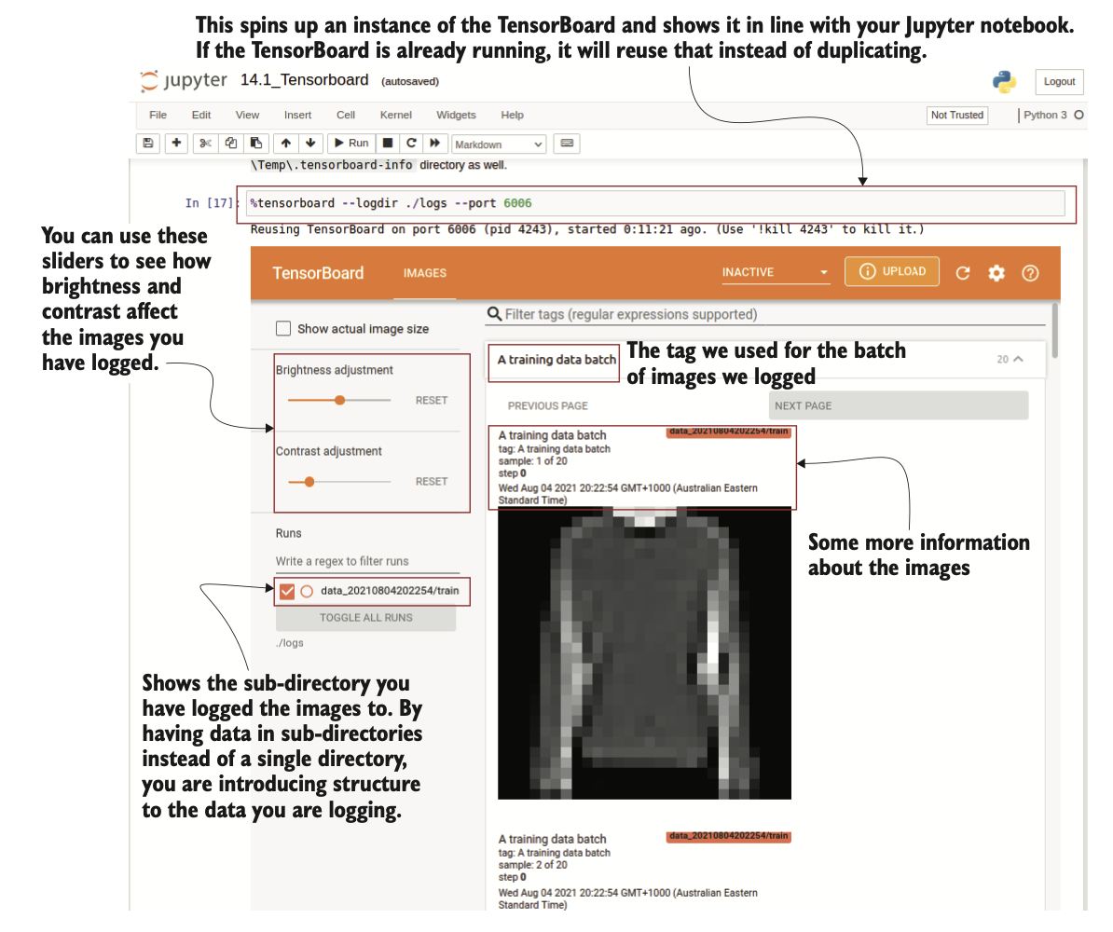
Figure 1 The TensorBoard visualizing logged images, displayed inline in the Jupyter notebook. You can perform verious operations on images, such as adjusting brightness or contrast
Once the data is clear, the next focus is monitoring model training. A dense neural network with layers of 512, 256, and 10 neurons is trained to classify the clothing samples. Metrics such as accuracy and loss are streamed into TensorBoard, producing evolving line plots. With real-time updates, one can toggle between training and validation results, smooth out fluctuations, or switch the scale to logarithmic for more interpretable long-range trends. Later, a convolutional model with filters of varying kernel sizes is introduced and trained on the same data. Because both models are logged into separate directories, their curves appear on the same dashboard, allowing side-by-side performance comparison. Activation histograms deepen the analysis by showing how neuron outputs distribute over time. Initially scattered, these activations gradually converge into recognizable patterns. A snapshot (Figure 2) reveals histograms stacked across epochs, darker tones representing more recent training, clearly showing convergence behavior.
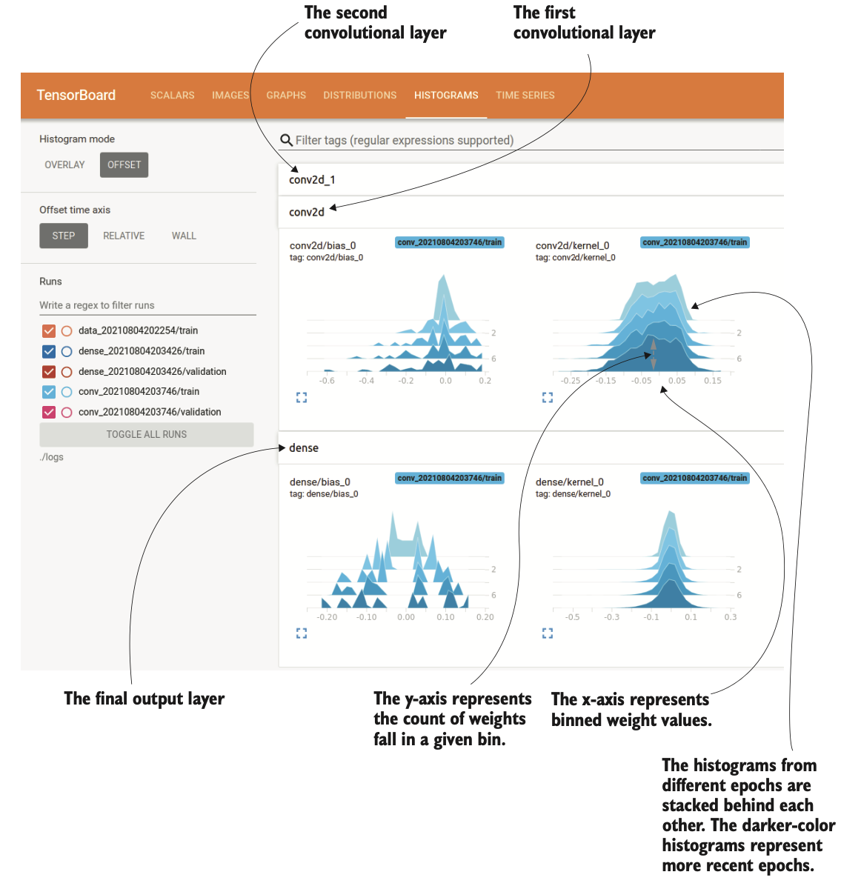
Figure 2 Activation histograms dipslayed by the TensorBoard. These graphs indicate how the distribution of activations in a given layer changed over time
Not every metric comes prepackaged. Sometimes a researcher may wish to measure internal properties, such as the mean and standard deviation of weight matrices. This is achieved by writing custom summaries within the training loop. By doing so, one can contrast two otherwise identical models—one with batch normalization and one without. Visualizations show how batch normalization introduces greater variability in weights, allowing them to adapt more flexibly. This insight, plotted as separate lines for mean and standard deviation (Figure 3), uncovers dynamics that would remain hidden if only accuracy or loss were tracked.
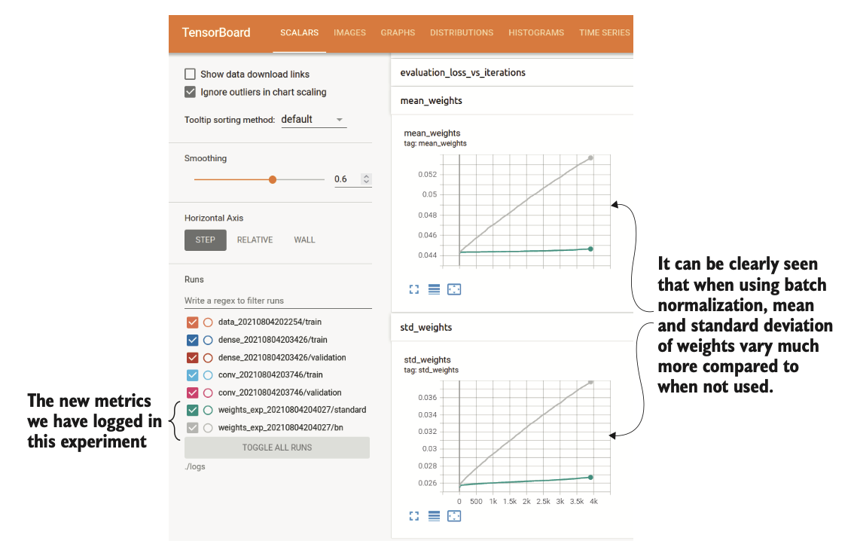
Figure 3 The mean and standard deviation of weights plotted in the TensorBoard
Performance, however, is not just about correctness. Training large networks often consumes significant time and memory, so profiling becomes crucial. Using a flower classification task with 17 categories, a deep convolutional model is trained while TensorBoard dissects the process into subtasks: input data time, kernel launches, GPU compute cycles, and communication overhead. Profiling reveals where most time is spent and offers suggestions—optimize the input pipeline, parallelize mapping, prefetch batches, or adopt mixed precision arithmetic. The shift to 16-bit operations leads to dramatic reductions in memory usage. A comparative memory profile (Figure 4) demonstrates how consumption drops from over 5 GB to nearly 1 GB, a 76% reduction, enabling larger models to fit comfortably within hardware constraints.
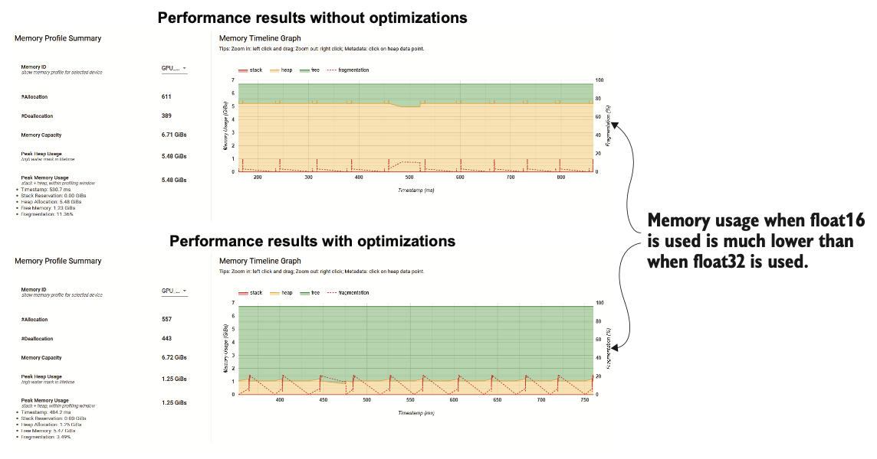
Figure 4 Memory profile with and without the optimizations. The difference from using 16-bit operations is very clear, as it has reduced the memory consumption of the model significantly
By combining visualization, monitoring, custom logging, and profiling, TensorBoard evolves into more than a diagnostic panel—it becomes an investigative instrument. It not only confirms whether a model is improving but also reveals how weights evolve, where computation stalls, and how memory is consumed. Its interactive views guide practitioners to refine data pipelines, tune architectures, and adopt efficient training techniques. In doing so, it transforms the invisible workings of neural networks into a transparent and navigable landscape, ensuring that the complex process of deep learning remains understandable, measurable, and ultimately controllable.

